Name:_________________________
Block:_________________________

Interpreting Velocity vs. Time Graphs

Recall:

$Slope=\frac{rise}{run}=\frac{y_{2}-y_{1}}{x_{2}-x_{1}}$ and when the y-axis is distance and the x-axis is time, then:

$Slope=\frac{d_{2}-d_{1}}{t_{2}-t_{1}}=velocity,$ meaning that the slope represents the velocity

Now let’s consider a velocity versus time graph. In this case, velocity is on the y-axis and time is on the x-axis so

$Slope=\frac{v_{2}-v_{1}}{t_{2}-t_{1}}$

Does this look familiar? This is the same calculation for acceleration!

∴ the slope of a velocity versus time graph is equal to the acceleration.

Term: | Looks like: | Means:
Positive acceleration | 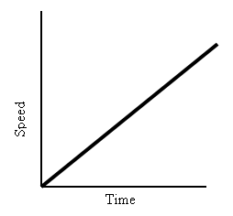
Negative acceleration | 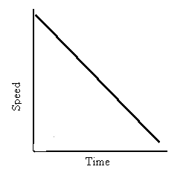
Zero acceleration | 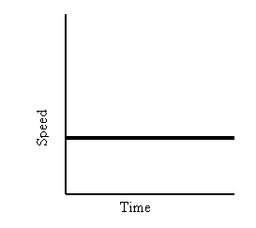
Which of these two objects has a greater acceleration? How do you know?

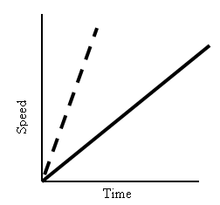

So to summarize, velocity is the slope of a displacement vs. time graph, and acceleration is the slope of a velocity vs. time graph. This means if we are given a displacement vs. time graph, we can sketch a velocity vs. time graph, and from this, we can sketch an acceleration vs. time graph.

Slope
Slope

Displacement Velocity Acceleration

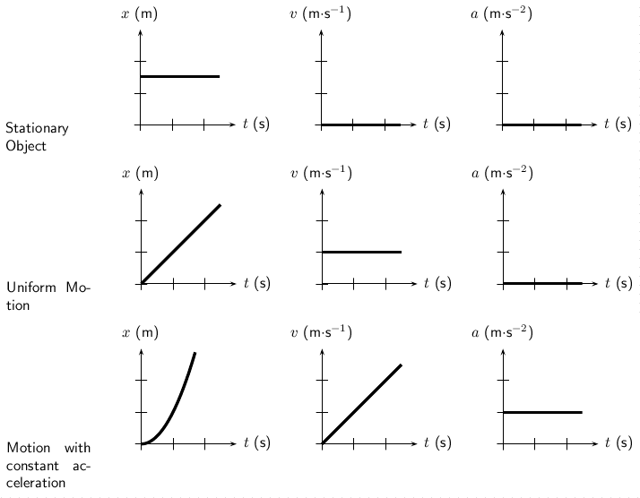

But that’s not all we can with graphs! Recall:

$\overset{⃑}{a}=\frac{\overset{⃑}{v}}{t}$ which we can rearrange to look like: $\overset{⃑}{v}=\overset{⃑}{a}∙t$

If we are looking at an acceleration vs. time graph where the y-axis is acceleration and the x-axis is time, multiplying these two values together will give us velocity. Also recall that multiplying a height (y-coordinate) by a width (x-coordinate) gives you area.

∴ The area under the curve of an acceleration vs. time graph is equal to the velocity

Similarly, on a velocity vs. time graph, multiplying the y-value (velocity) times the x-value (time) gives you displacement:

$\overset{⃑}{v}=\frac{\overset{⃑}{d}}{t}$ rearranged looks like, $\overset{⃑}{d}=\overset{⃑}{v}∙t$

∴ The area under the curve of a velocity vs. time graph is equal to displacement

Slope
Slope

Displacement Velocity Acceleration
Area
Area

