Phi, Rational Expressions, and Life

Phi = Φ = “golden number”

Phi has two unique characteristics:

- $Φ^{2}= Φ+1$
- $\frac{1}{Φ}= Φ-1$

Phi is based on the golden ratio:

B A

$$\frac{A+B}{A}= \frac{A}{B}= Φ$$

But what is the value of $Φ?$ $Let B=1$

Then the equation becomes:

$$\frac{A+1}{A}= \frac{A}{1}= Φ ∴ A= Φ$$

And if we simplify this expression, it becomes:

$Φ$ + 1 = $Φ^{2}$

Which can be rearranged:

${0=Φ}^{2}- Φ-1$

Using the quadratic formula, we find:

$$Φ= \frac{1 ± \sqrt{5}}{2}=1.6180339…, -0.6180339…$$

Golden ratio = $Φ$ = $1.6180339…$

Why do we care?!!!!!

Phi can be used to compute the nth number in a Fibonacci series

$$f_{n}= \frac{Φ^{n}}{\sqrt{5}}$$

So what?

Fibonacci’s sequence:

0, 1, (0 + 1)
0, 1, 1, (1 + 1)
0, 1, 1, 2, (1 + 2)
0, 1, 1, 2, 3, (2 + 3)
…
0, 1, 1, 2, 3, 5, 8, 13, 21, 34, 55, 89, 144, …

SO WHAT?
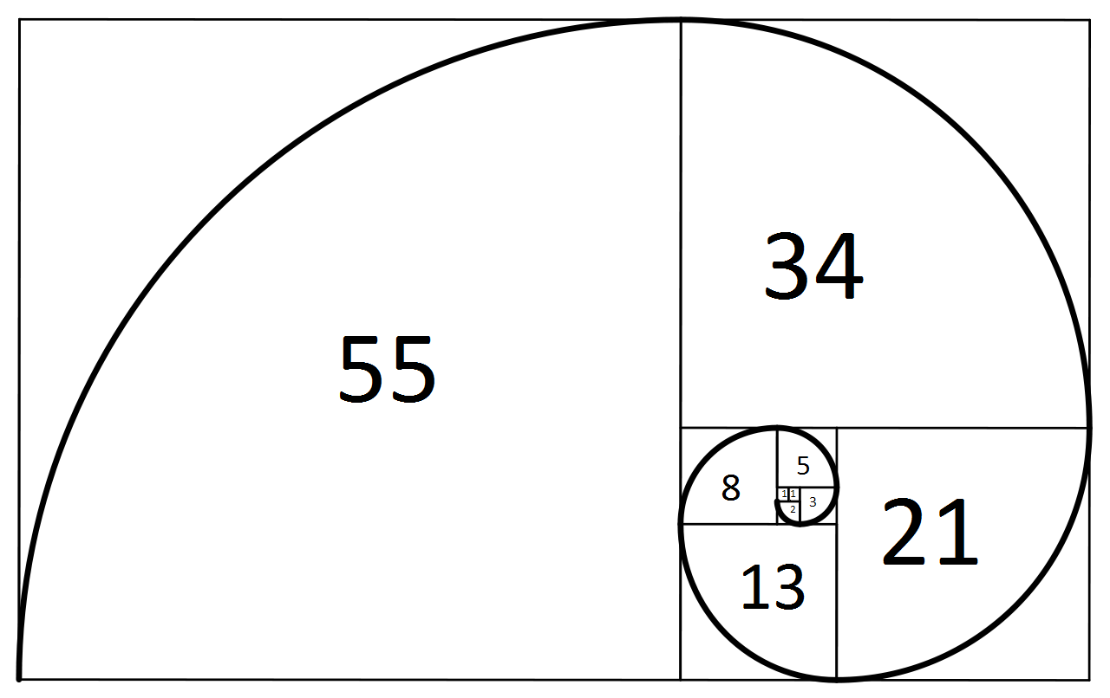

SO WHAT?!!!!!

Let’s watch.

https://www.youtube.com/watch?v=P0tLbl5LrJ8

